Installation Instructions for the COMPLY v2.0 beta Release (revision 1)
October 26, 2026

- BACKGROUND

COMPLY is a screening tool for evaluating radiation exposure from atmospheric releases of radionuclides. The tool may be used for demonstrating compliance with some EPA and Nuclear Regulatory Commission regulations, including the National Emission Standards for Hazardous Air Pollutants (NESHAPs) in 40 CFR Part 61, Subpart H and Subpart I. COMPLY-R is specified for showing compliance with NESHAPs Subpart B Radon Emissions from Underground Uranium Mines. COMPLY v2 provides a software update to both COMPLY and COMPLY-R.

COMPLY v2 calculates the dose [mrem/yr effective dose equivalent (EDE)] from radionuclides released from stacks and vents. The code models the atmospheric dispersion of the radioactive air effluent and estimates air concentrations using a Gaussian plume model. COMPLY v2 includes multiple modules (levels) representing increasing complexity related to source-receptor relationships and dose estimation. Level 1 requires the least amount of information: emission concentration or quantity possessed. However, under Level 1, "worst case" assumptions are used in the dose estimate. Level 4 requires the most detailed information rather than assuming generic worst-case parameters. The values estimated by this screening model are strictly for comparison with environmental standards and are not intended to represent actual doses to real people.

- CODE DISTRIBUTION

Links are provided for the COMPLY v2 beta code in Table 1. The code is provided in a compressed archive ZIP and TAR format. Both files have the exact same files included in the compressed archive. Users should select either the ZIP or TAR file and do not need to get and uncompress both.

Table 1. Links to compressed archive format files of the COMPLY v2 code.
https://gaftp.epa.gov/aqmg/baker/comply/v20_beta2.zip

A list of files (except for the ZIP and TAR archived files) in each of the distributed archived ZIP and TAR files is shown in Figure 1. The directory contains the regular output and diagnostic output generated for each of the different levels (Level 1, 3, 4, and 4r) associated with each of the input files. This is intended to facilitate a benchmarking comparison to results generated by the model developers, so users know whether the model is correctly functioning on their computer system.

Figure 1. Files distributed with COMPLY v2.
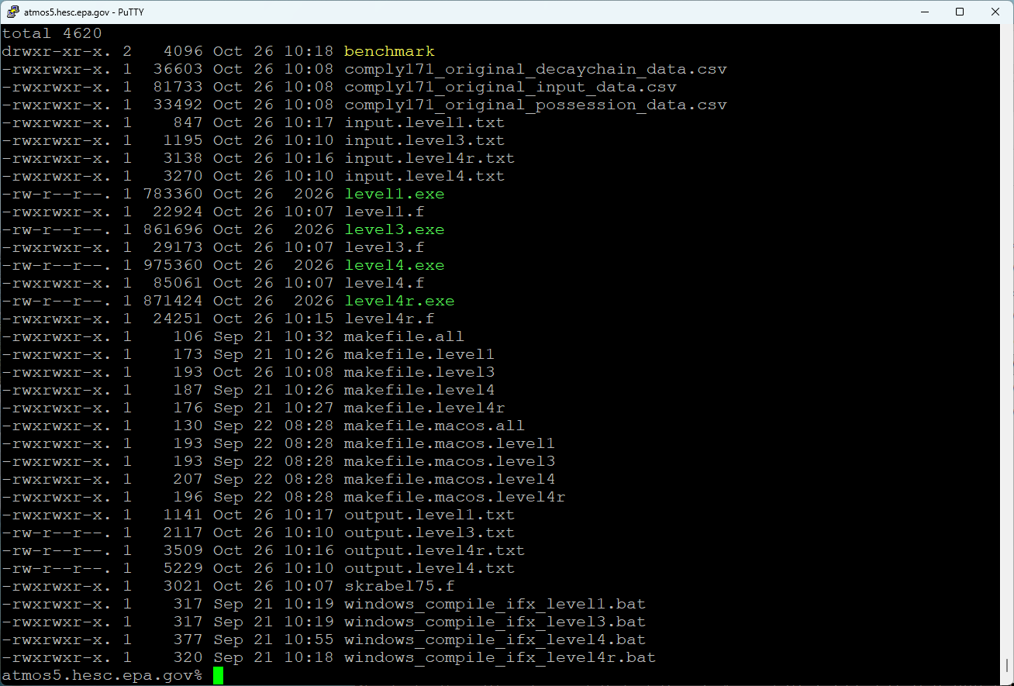

The comply171_original* files are comma delimited text format files with nuclide-specific parameters. These files can be opened, browsed, and edited with any text editor or common programs such as Microsoft Excel. If imported into a program like Excel it is possible the user may be prompted to convert the file format to the standard text comma delimited file format used by Excel. Selecting either yes or no to that prompt from Excel will not change the model predictions in the file.

- CODE INSTALLATION

Steps for installing COMPLY v2 on various computing systems follows.

Windows Computing System

The COMPLY code is distributed with pre-compiled Windows executables in a file archive (zip file). There is no installer package! The files just need to be placed in a folder where the user would like them to be located and if the precompiled executables do not work the user may need to compile the fortran code with a compiler. More details follow.

- Create a new directory on your computer to keep COMPLY v2 code
- Download the ZIP or TAR file with the COMPLY v2 code from the link, then put the code in the new directory you created for COMPLY v2
- Extract files from the archived packages into the new directory
- Test the executables distributed in the archived package to see if they work without being compiled on your system (see next bullet if compiling is needed)
  - Ensure that the model input files (comply171_original* and input.level* files) are in the same directory as the executables
  - Double-click on level1.exe. If the model runs to completion and a new output file is generated matching the output file for level 1 in the “benchmarking” folder, then no further action is needed to compile the executables on your system.
  - Test the other executables: level3.exe, level4.exe, and level4r.exe
- If it is necessary to compile each of the levels of COMPLY v2 on your Windows computer system double-click on each of the batch (*.bat) files that to execute code compilation with the Intel Fortran compiler. Afterward, double-click on the executables to test operability (level1.exe level3.exe, level4.exe, and level4r.exe).
- windows_compile_ifx_level1.bat
- windows_compile_ifx_level3.bat
- windows_compile_ifx_level4.bat
- windows_compile_ifx_level4r.bat

Linux Computing System

- Obtain a Fortran compiler compatible with your Linux OS. The makefiles distributed with this code were developed using the Intel Fortran compiler.
- Create a new directory on your computer to keep COMPLY v2 code
- Obtain the ZIP or TAR file with the COMPLY v2 code and put the code in the new directory created for COMPLY v2
- Extract files from the archived packages into the new directory
- Compile each of the levels of COMPLY v2 on your computer system.
- make -f makefile.all

Mac Computing System

- Obtain a Fortran compiler compatible with your Mac OS. The makefiles distributed with this code were developed using GFORTRAN for MacOS.
  - https://gcc.gnu.org/wiki/GFortranBinariesMacOS
- Create a new directory on your computer to keep COMPLY v2 code
- Obtain the ZIP or TAR file with the COMPLY v2 code and put the code in the new directory created for COMPLY v2
- Extract files from the archived packages into the new directory
- Compile each of the levels of COMPLY v2 on your computer system.
- make -f makefile.macos.all

- CODE APPLICATION

This section provides instructions for running COMPLY v2 on your computer system. These instructions are generally applicable to each of the levels distributed with COMPLY v2. Here, the example is for “level 4r” which refers to the COMPLY-R version level 4.

- First, edit the input file "input.level4r.txt" with a text editor to reflect the stack characteristics, emissions amounts for each radionuclide, meteorological data, receptor distances, and other relevant information for your scenario.
- COMPLY v2 expects the input file to be called “input.level4r.txt” so after running a file, it is recommended that the input and output file are copied into a project-specific folder and re-named something unique for posterity (e.g., adding a stack, receptor, or emissions indicator). Accordingly, recycled project specific files would be changed back to this standard filename convention before re-running the model.
- It is important to recognize that the wind directions represent winds from a particular sector and the downwind receptor locations represent winds toward a particular (downwind receptor) sector.

For example, NNE is the sector that the wind is blowing FROM, the frequency is the wind frequency from that sector, the speed (m/s) is the wind speed from that sector, the "15000" value represents the distance downwind of the stack to the maximum exposed individual (MEI) and SSW is the downwind sector where the MEI is located relative to the source (wind blowing TO this sector). Table 2 shows the ranges for sectors and degrees useful for data processing.

Table 2. Cardinal directions for winds and downwind receptors as implemented in COMPLY v2.
Sector FROM for Winds | Sector Degrees FROM |  | Sector TOWARD for Receptor Location | Sector Degrees TOWARD
N | 348.75-360 and 0-11.25 |  | S | 168.75-191.25
NNE | 11.25-33.75 |  | SSW | 191.25-213.75
NE | 33.75-56.25 |  | SW | 213.75-236.25
ENE | 56.25-78.75 |  | WSW | 236.25-258.75
E | 78.75-101.25 |  | W | 258.75-281.25
ESE | 101.25-123.75 |  | WNW | 281.25-303.75
SE | 123.75-146.25 |  | NW | 303.75-326.25
SSE | 146.25-168.75 |  | NNW | 326.25-348.75
S | 168.75-191.25 |  | N | 348.75-360 and 0-11.25
SSW | 191.25-213.75 |  | NNE | 11.25-33.75
SW | 213.75-236.25 |  | NE | 33.75-56.25
WSW | 236.25-258.75 |  | ENE | 56.25-78.75
W | 258.75-281.25 |  | E | 78.75-101.25
WNW | 281.25-303.75 |  | ESE | 101.25-123.75
NW | 303.75-326.25 |  | SE | 123.75-146.25
NNW | 326.25-348.75 |  | SSE | 146.25-168.75

- Execute the model.
- If using a non-command line interface, double-click on the level4r.exe executable to perform the model simulation.
- If using a command line interface, type the executable name to perform the model simulation.
- Output will automatically be generated into files called output.level4r.txt and diag.level4r.txt.
- The output* file contains information for the compliance demonstration and the diag* file (diagnostic file with more detailed additional distance assessments) contains receptor and radionuclide specific information for various receptors that can be used to supplement the compliance results.
- The output.level4r.txt and diag.level4r.txt files should be compared to those generated by the EPA software developer located in the /benchmarking folder to provide a measure of quality assurance that the model is running correctly on your system.

